**Synopsis**

**On**

**Face Mask Detection**

**to be developed to fulfill the requirements for**

**Major Project (CA133)**

**Submitted to**

**Department of Computer Applications**

**Chitkara University, Punjab**



**under the supervision of**

**Dr. Amandeep Bhullar**

**Submitted by**

Yatin Bajaj Abhinav Sharma

1810992625 1810992633

**Bachelor of Computer Applications**

**(Batch 2018-21)**

**TABLE OF CONTENTS**

**1. Abstract**

**2. Introduction**

2.1 Project Aim and Objectives

2.2 Technology to be Used

2.3 Hardware and Software Requirement

**3. System Analysis**

3.1 Software Requirement Specification

3.2 Existing v/s Proposed System

3.3 Software tools to be used

**4. Data Flow Diagram**

**5. Timeline**

**6. References**

### Abstract

As the virus outbreak continues, business leaders are coming up with innovative digital solutions. One of them is a face mask detection system to identify people with face masks. According to data obtained by the World Health Organization, the global pandemic of COVID-19 has severely impacted the world and has now infected more than eight million people worldwide. Wearing face masks and following safe social distancing are two of the enhanced safety protocols need to be followed in public places in order to prevent the spread of the virus. Our project is a real-time application to detect people if they are wearing a mask or are without a mask. This project can be put into action in public areas such as airports, railways, schools, offices, etc. to check if COVID-19 guidelines are being followed or not.

### Introduction

The year 2020 has shown mankind some mind-boggling series of events amongst which the COVID-19 pandemic is the most life-changing event which has startled the world since the year began.Affecting the health and lives of masses, COVID-19 has called for strict measures to be followed in order to prevent the spread of disease [1]. From the very basic hygiene standards to the treatments in the hospitals, people are doing all they can for their own and the society’s safety; face masks are one of the personal protective equipment. People wear face masks once they step out of their homes and authorities strictly ensure that people are wearing face masks while they are in groups and public places.

To monitor that people are following this basic safety principle, a strategy should be developed. A face mask detector system can be implemented to check the safety guidelines. Face mask detection means to identify whether a person is wearing a mask or not [2]. The ﬁrst step to recognize the presence of a mask on the face is to detect the face, which makes the strategy divided into two parts: to detect faces and to detect masks on those faces. Face detection is one of the applications of object detection and can be used in many areas like security, bio-metrics, law enforcement and more[3]. There are many detector systems developed around the world and being implemented. However, all this science needs optimization; a better, more precise detector, because the world cannot afford any more increase in corona cases.

In this project, we will be developing a face mask detector that is able to distinguish between faces with masks and faces with no masks. In this report, we have proposed a detector which employs for face detection and a neural network to detect presence of a face mask.

#### 2.1 **Project Aim and Objectives**

Aim is to build a real-time desktop application to automate the process of screening performed in the public areas to enforce people to wear masks.However, by this

application people without masks will be detected through CCTV surveillance in the public areas, and it will be easy for the local authorities to take action on the people not following the COVID-19 guidelines.

**2.2** Technology to be used

In this project, we are using a subset of computer vision i.e. object detection, it is an automated way of locating objects with respect to the background. To perform object detection, there are some libraries by which we could implement object detection i.e. openCV(4.2.0) and tensorflow(1.15.2). openCV is used to access and manipulate data(video stream through webcam) and tensorflow is used to train the model with data handling. Keras(2.3.1) library contains some API’s that are used by tensorflow to train the model.

**2.3** Hardware and Software Requirement

|  |  |  |
| --- | --- | --- |
| **Hardware Requirements:** | **Minimum** | **Recommended** |
| **Processor** | Intel i3-6100 @ 1.7GHz or  AMD Athlon X4 770K @2GHz. | Intel i5-4400 @2.30GHz. |
| **Operating system** | Windows 8 - 64-Bit | Windows 10 – 64-Bit |
| **Memory** | 4GB RAM. | 8GB RAM. |
| **Hard disk space** | 1GB available space. | 2.5GB available space. |

**3.** System Analysis

**3.1 Software Requirement Specification**

* General Description:

To automate the screening of COVID-19 guidelines and to impede the spread of corona virus. It also saves the time of stake holder and the man power is also benefited.

* Functional Requirements:

1. System can detect face of people.
2. The system must be attached to the webcam and face recognition should be smooth.

* Interface Requirements:

This module captures a video stream and then captures our image from the stream, and then detect whether a person is wearing mask or not.

* Performance Requirements:

Minimum Requirements: i3-8th gen, 4gb RAM, 1gb HDD, python 3.6 and above and some python-based libraries.

Recommended Requirements: i5-4th gen, 8gb RAM, 1gb HDD, python 3.6 and above and some python-based libraries.

* Non-Functional Requirements:

1. The system will avoid crashes.
2. The application is portable and can be used on another windows PC.

**3.2** **Software Tools to Be Used:** Pycharm or Jupyter Notebook

1. **Data Flow Diagram**

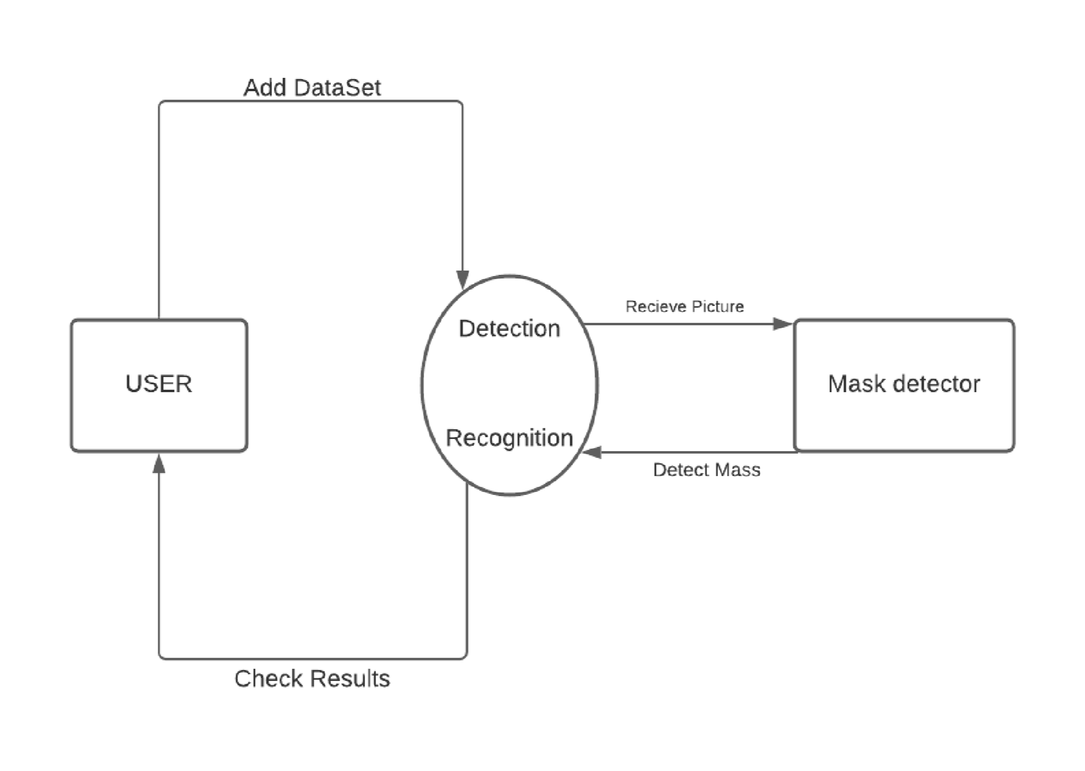

|  |  |  |  |
| --- | --- | --- | --- |
|  | **1 Dec - 12 Dec**  **2020** | **14 Dec – 26 Dec**  **2020** | **29 Dec – 8 Jan**  **2020** |
| **Synopsis Submission** |  |  |  |
| **Implementation** |  |  |  |
| **Report Writing** |  |  |  |
| **Final submission** |  |  |  |

**5. Timeline (Suggested)**

**6. References (IEEE)**

1. Benjamin Bergner, Prof. Dr. Christoph Lippert,Raza Ali,Akhyar Ahmed,Saniya Adeel, facemask detector,July 2020 DOI: 10.13140/RG.2.2.32147.50725 Affiliation: Universitat Potsdam

“Artificial Intelligence”.

Available: <https://www.researchgate.net/publication/344173985_Face_Mask_Detector>

1. Vinitha.V1, Velantina.V, "COVID-19 FACEMASK DETECTION WITH DEEP LEARNING AND COMPUTER VISION", Volume: 07 Issue: 08 | Aug 2020 "Student, Department of Master of Computer Application, AMC Engineering College Bangalore, Karnataka, India ".

Available: <https://www.irjet.net/archives/V7/i8/IRJET-V7I8530.pdf>

1. Feng S., Shen C., Xia N., Song W., Fan M., Cowling B.J. Rational use of face masks in the COVID-19 pandemic. Lancet Respirat. Med. 2020;8(5):434–436. doi:10.1016/S2213- 2600(20)30134-X.
2. Sandler, Mark, Andrew Howard, Menglong Zhu, Andrey Zhmoginov, and Liang-Chieh Chen, "Mobilenetv2: Inverted residues and linear bottlenecks," IEEE Conference on Computer Vision and Pattern Recognition, pp. 4510-4520. 2018.
3. S. Feng, C. Shen, N. Xia, W. Song, M. Fan, and B. J. Cowling,“Rational use of face masks in the covid19pandemic,”The Lancet Respiratory Medicine, 2020.